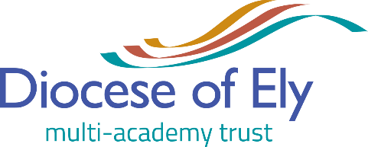

Ermine Street Church Academy
(a part of the Diocese of Ely Multi-Academy Trust)
is seeking to appoint an
1:1 Teaching Assistant (Part-Time, 22.5 hours, 9.30-1.40 daily)

Payscale: Spine point 3-4 depending on experience (£18,065-£18,426 fte)
22.5 hours per week.
Start date: As soon as available to take up the post.

Ermine Street Church Academy is on an exciting journey and we would love you to join us!

We are looking for a proactive, child-focused Teaching Assistant to work with a child who has recently been approved for an Education Health and Care Plan.

We are looking for
- A calm but pro-active person who will support the child’s speech and learning to move forward.
- A person who nurtures children whilst also consistently implementing clear boundaries and improvement strategies.
- A strong team player.
- A person who demonstrates excellent initiative.

We can offer you:
- Excellent support from our dedicated team of staff.
- Resources and spaces to provide exactly what children need.
- Specific training.
- A school committed to staff well-being.

Visits to the school are warmly welcomed and encouraged, to arrange an appointment please call:
Mrs Mathews, Business Manager on 01480 276510. Applications may be returned by email to: businessmanager@erminestreetca.org.uk

Closing date: 3rd October 2019 (9am)
Interviews: Week commencing 7th October 2019

We would like to advise if you have not heard from us by the end of 7th October 2019 then on this occasion you have not been successful in securing an interview and that, due to the large volume of applications, it will not be possible to respond to every applicant. We would like to thank you for your interest in working with us, and if you do not receive an interview this time please do not let this stop you applying for further posts advertised across DEMAT in the future.

The Diocese of Ely Multi-Academy Trust (DEMAT) is an equal opportunities employer and employs suitably qualified persons regardless of their race, sex, disability, religion/belief, sexual orientation or age. We are committed to safeguarding and promoting the welfare of children and young people and expect all staff to share this commitment. Any appointments will be subject to satisfactory medical checks, references and an enhanced DBS check.

